The Fort Nelson
Community
Literacy Society
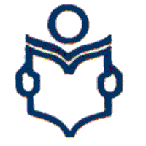

Family Literacy Program

What is literacy anyways?
When asked what “Literacy” means, most of us will reply with something along the lines of, “Reading and writing, right?” That’s not an entirely wrong answer but literacy is so much more and I can guarantee it affects your life in ways you may not realise.
There are many definitions for literacy:
- Literacy is the ability to understand and employ printed information in daily activities, at home, at work and in the community. It is not about whether or not one can read but how well one reads. (Literacy BC)

- To be literate means that you have the skills to understand what you read, communicate with others and engage fully and confidently in life’s activities and opportunities – at work, at home and in the community. (ABC Canada)

- Everyone has the right to participate fully and be included in their community. Literacy is much more than reading and writing, it also means being connected to your language and culture. Literacy involves everyone and is fundamental to the development of health and well-being. Literacy is fostering and nurturing understanding, knowledge and wisdom. (Developed at a literacy summit in Arviat.)

- Literacy is the lifelong development of a broad range of skills with the purpose of expanding an individual’s potential for optimal health, personal success and positive participation in community wellness and development. (Literacy Strategy for Government of the NWT)

- Literacy, numeracy and problem solving are essential to function in today’s world. For individuals, they are the key to realizing their full economic and social potential and the foundation upon which they acquire additional knowledge and skills throughout adulthood. They are strongly associated with individual outcomes and enable people to participate in their communities, make wise consumer decisions, and construct social networks. (International Adult Literacy and Skills Survey)

Think about the tasks you accomplish before leaving the house.
- Showering or bathing
- Preparing a meal
- Watching the news or reading the newspaper
- Getting children ready for the day
- Organizing finances/banking
- Writing a grocery list
All of these activities are examples of literacy in action. Take a minute and think about how many of your daily activities involve reading, writing and math. By strengthening these skills you empower yourself and your family.

So what is “Family Literacy”?

Family literacy refers to the many ways families learn together. Parents and caregivers are their children’s first and most important teachers.

Some examples of family literacy are:
- writing a thank you note
- going for a walk
- learning about culture and traditions
- making a meal together or sharing stories before bedtime
- playing a board game

Why is it important?
Current research shows that early experiences help to shape how we think and react to things later in life. It is important to start early. Reading, singing, talking and being close to your baby or child are really important activities. They help children’s brains grow and help them learn language.
- Reading, singing, storytelling and talking play an important part in your child's language development.
- Strong literacy skills start with strong language development.
- Children who start school with strong language and literacy skills have fewer problems at school, are less likely to drop out and have a much higher chance of going on to complete high school.
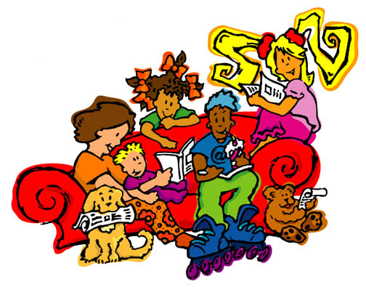
- Parents who show their children that learning is important are more likely to have children who value reading, learning and education.

The literacy skills of parents directly affect their family’s income, health and overall quality of life

What do Family Literacy Programs look like?

Family literacy programs provide learning activities and opportunities for parents, caregivers, children and other members of the family. Some examples of family literacy activities are:
- The 1-2-3 Rhyme with Me program promotes young children’s oral language development through the use of rhymes, songs and stories. The program is directed at parents and teaches them the skills they need to enhance their children’s oral language development. Good language development at a young age will help children develop good literacy skills in the future.

- The Books in the Home program is based on the belief that parents are children's first and most important teachers. In this program, parents learn to read and share books with their children in positive and enjoyable ways. The program promotes reading and writing of both parents and children.

- Reading circles encourage parents and other community members to help children become enthusiastic and positive about reading. In a reading circle, parents, community members and children meet once a week for an hour to share stories and books. The focus is on discussion, and the enjoyment of families reading and talking together. The reading circle is informal, and can be easily integrated into existing programs and services for families.

Special family literacy events that encourage literacy related activities for holidays. These activities will include: storytelling, sewing, crafts, cooking traditional foods, celebrating holidays like Christmas, Valentine’s Day, etc
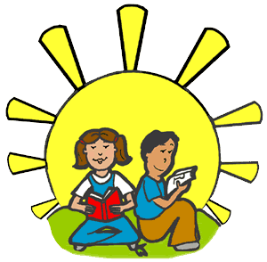

Aboriginal Family Literacy Component
Aboriginal literacy is a complex issue, involving the need to heal, and to reclaim identity, language, culture, and self-determination.
An Aboriginal focused Family Literacy Program must be built upon these key concepts:
- a learner-centered approach to literacy skills development which links literacy to real issues in learners' lives. This allows the learner to set learning goals ensuring respect for and empowerment of the learner

- a community-based approach in which Aboriginal people identify their own educational needs and develop solutions to the literacy issue within their communities, drawing on some of the traditional strengths and wisdom of Aboriginal communities
- a holistic approach to skills development ensuring the individual is respected as a whole person who is part of a family, a community and a Nation

- program diversity and a variety of teaching method options reflecting the wide diversity of Aboriginal Nations providing literacy services

- a culturally based approach to literacy training that ensures respect for the learner and takes into account prior learning and experiences.

- literacy training that considers the need for increased interactions between Natives and non-Natives on an equal basis. (Ontario Native Literacy Coalition, 1999)

Some examples of Aboriginal Family Literacy Programs are:
- Books and Bannock – Families come together once a week to read and eat bannock.

- Elders and Children – Elders tell stories to the children. They talk about the past and what it was like when they were young.

- Traditional Skills – Each week, Elders teach boys and girls traditional skills.

Why is the use of Aboriginal Language important?

Language is immensely important because it symbolizes, in a very concrete way, the cultural group we belong to. Language embodies culture: we use it to define our world and make sense of it. It shapes the way we look at the world, giving us our worldview. We use language to transmit our culture and worldview from one generation to the next. (Multiple Literacy’s, NWTLC)
To support Aboriginal language:
- Develop Aboriginal language books and resources.
- Use storytelling in your program and community.
- Create fun games in your language and teach them to families.
- Encourage local teachers, early childhood workers to speak to the children and young people in your language on the play ground and in the halls of the school.
- Develop posters with positive messages about speaking your Aboriginal language.
- Create a language committee that promotes culture and language in your community.
- Develop a plan for maintaining and/or revitalizing your Aboriginal language.
- Encourage parents to speak their language in the family.

How do children learn language:
- No language is too hard for a child to learn. Children can easily learn more than one language or dialect at a time. A child can master up to 90% of a language in the first four years!
- For many years, Aboriginal parents and educators were told that education in an Aboriginal language, whether through immersion or bilingual education, would be harmful to the children’s education. As linguists and specialists in education now know, the opposite is actually true. Learning an Aboriginal language from an early age in the home, daycare, pre-school or community enhances the social, emotional and intellectual development .

